**Interfacing HAP Simulations with GLD**

The purpose of this document (modified from a HAP ehelp file) is to demonstrate how cooling and heating load data required by the GLD software can be derived from Carrier HAP energy simulation results.

**Introduction**

GLD considers many variables when calculating the geothermal heat exchangers. For example, in the design of a vertical loop system, GLD analyzes loads requirements, borehole depth, spacing, and quantity, along with piping lengths, soil thermal conductivity, and fluid properties. The role of HAP is to generate the load that GLD uses to optimize the heat exchanger design. Both cumulative loads and peak loads for all months of the year are required to take advantage of GLD’s full analysis capability.

GLD Load Requirements:

1. Total monthly cooling coil load (kBTU) (cumulative effects)

2. Maximum hourly cooling coil load (BTUH) (peak magnitude)

3. Total monthly heating coil load (kBTU)

4. Maximum hourly heating coil load (BTUH)

Items 1 and 3 can be obtained directly from the HAP Monthly Simulation Results report

for aWSHP air system shown on page 3.The Monthly Simulation Results contains monthly totals of loads and energy consumption for the system.

Finding items 2 and 4 ismore involved.

The procedure is summarized below and then demonstrated with a detailed example.

**PROCEDURE SUMMARY**

1 Create the geothermal WSHP system model in HAP.

2 Run energy simulation for geothermal WSHP system in HAP and generate the

Monthly Simulation Results (tabular version) and Hourly Simulation Results (ASCII text version, Jan 1 thru Dec 31).

3 Use the Monthly Simulation Results report to obtain the monthly cooling and heating load totals.

4 Use Excel to import the TXT file containing the Hourly Simulation Results into an XLS spreadsheet template provided by Carrier. Click link below to download this file.

<http://www.groundloopdesign.com/downloads/Other/E20_GSHP_MAX_MONTHLY_COIL_LOAD.xls>

5 Use the summary table at the bottom of the XLS spreadsheet to obtain the monthly peak cooling and heating loads. This table uses the Excel MAX function to identify the peak load for each 1 month block of results.

6 Enter the monthly cooling and heating loads plus the monthly peak cooling and heating loads into GLD to perform the heat exchanger sizing analysis.

**DETAILED EXAMPLE**

The following example demonstrates the creation and transfer of load data into GLD.

**Step 1:** Set up the geothermal WSHP HAP model per HAP eHelp 002 dated October 1, 2005, “How to Model WSHP/GSHP Systems Using Carrier HAP Software.” Pay special attention to example C. Ground Coupled WSHP System on page 3.

**Step 2:** Right click on the WSHP air system and Print View Simulation data. Our example air system is called Geo Zones All.

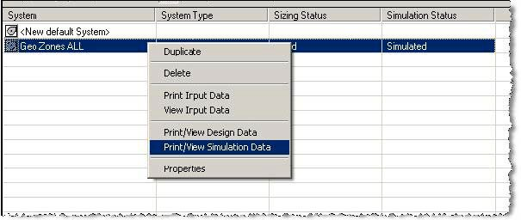

**Step 3:** Ask for the Monthly Simulation results and the Hourly Simulation Results TXT file. Hourly results must be for all year.

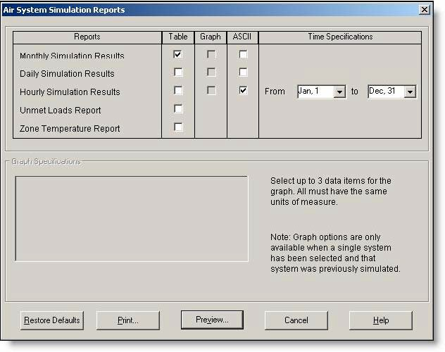

**Step 4:** Collect the monthly air system coil loads from the WSHP Cooling Coil and Heating Coil Load columns. These can be seen below.

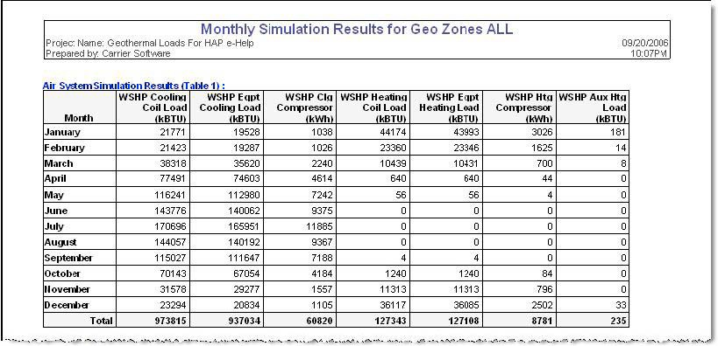

Open a new worksheet in excel and label four columnsso that they follow the format inside the GLD loads module (Please note that the columns MUST be in this order for accurate transfer into GLD: total cooling, peak cooling, total heating, peak heating):

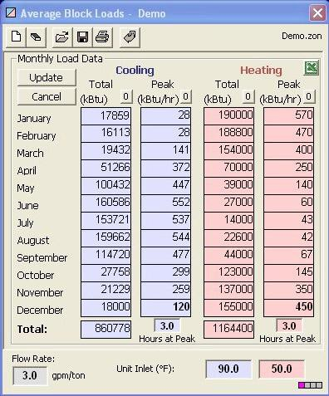

Paste the WSHP Cooling Coil and Heating Coil Load columns into their respective Total cooling and Total heating columns in the new worksheet. Next we will retrieve the remaining load data. The Hourly Simulation Results TXT file is created by checking the box in the Air System Simulation Reports.

**Step 5:** Open the blank Excel worksheet (GSHP Max Monthly Coil Loads.xls), the link to which is found on page 1 of this document. This Excel file has been provided as a convenience. It is used to import the TXT file created in step 3. It has been configured to accept the TXT file import from HAP and find the maximum hourly heating and cooling load for each month of the year.

**Step 6:** Highlight the upper left cell in the Excel worksheet (A1).

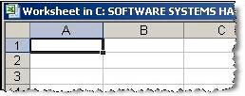

**Step 7:** Go to: Data > Import External Data >Edit Text Import in the Excel worksheet:

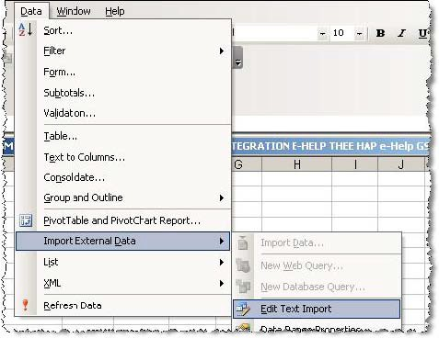

**Step** 8**:** Browse to the TXT file of the appropriate HAPProject folder under E20II and import it**.** When you generate the ASCII report as we did in Step 3, the program tells you where the file is located as seen below: The TXT file name will always start with program name(“HAP43”) followed by the report type (“Hourly”)followed by the air system name (in this example, our air system was named “Geo Zones All”).

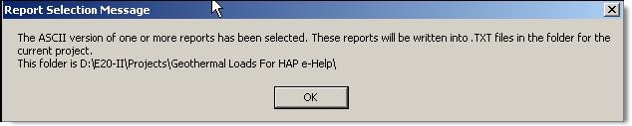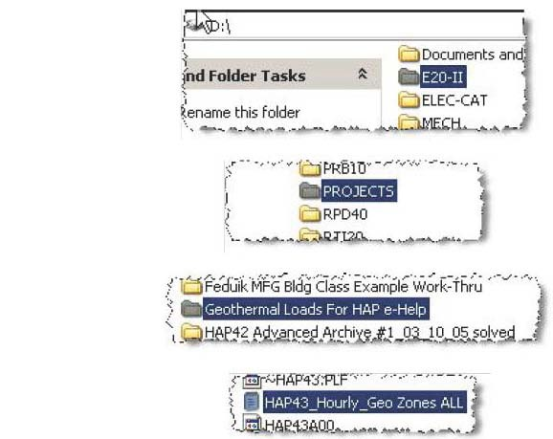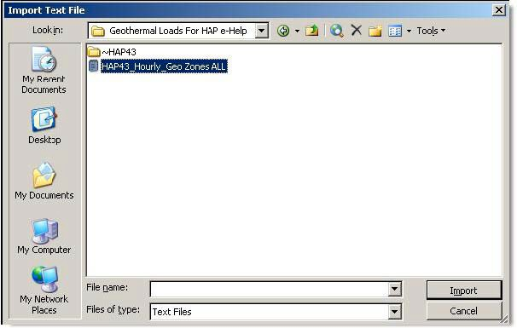

**Step 9:** This launches a 3 step import Wizard in Excel. Just press **"Next" twice then "Finish"** using all default import settings.

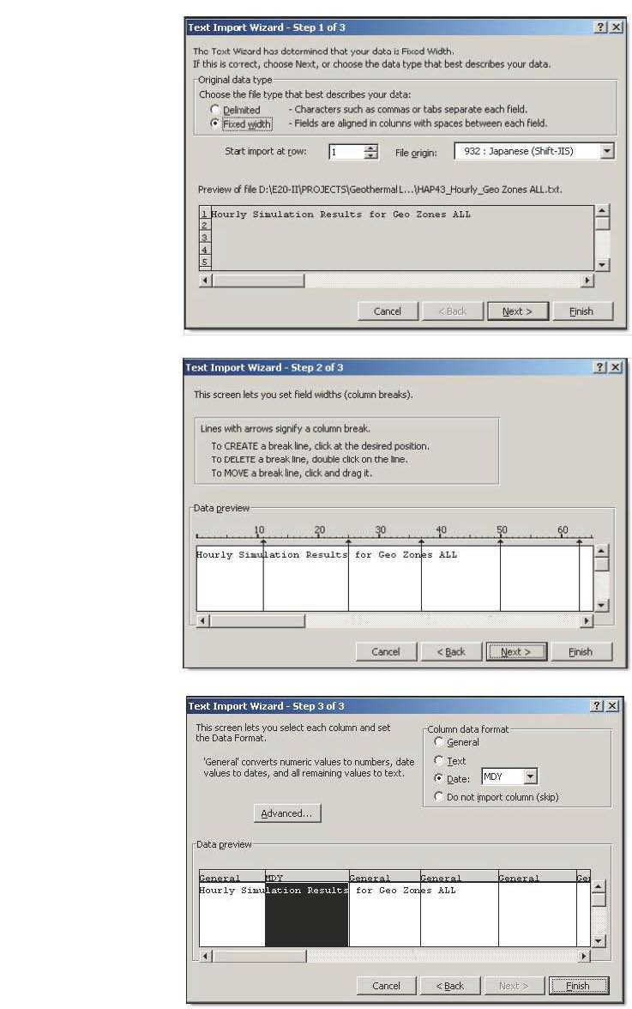

**Step 10:** Using the vertical slider **scroll down to the bottom (below row 8760)** and you see a table for each of the 12 months containing max cooling and heating coil loads for each month!

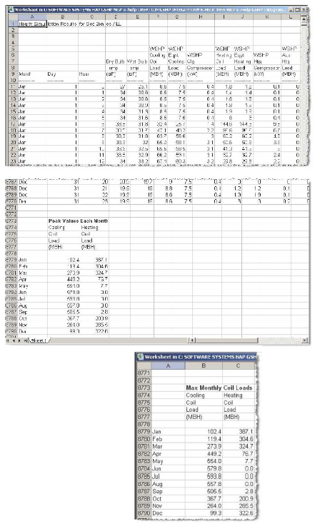

Copy these data into the excel worksheet that you created in Step 4 above. Again, confirm that the four columns follow this format:

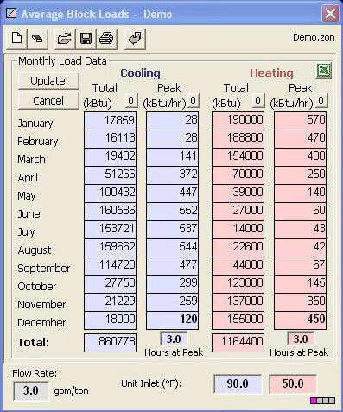

**Step 11:** Select and copy (ctrl-C) the four columns of data (be sure to copy only the data and not any column labels that you might have added. In GLD, hit the Excel icon (as can be seen above) to import the data into the AVERAGE BLOCK loads module.

**Questions?**

Contact us at [www.groundloopdesign.com](http://www.groundloopdesign.com/)